1. OAuth is an open authentication and authorization framework.
2. It will allow one application to gain access to user’s data within other application without the user sharing his user id and password with this application.
3. **For Example**:
   1. Let’s say we’re using a tax filing website to file our tax returns.
   2. This tax filing website, instead of asking us to register and create a user login, it ask us to log in **through** Facebook using our Facebook user id and email.
   3. Once we log in, the tax filing website will be able to access just the profile information from Facebook.  
      Not our pictures, not the videos.
   4. This entire flow is possible through the Oauth standard or Oauth framework.   
      Similarly at the end of the tax filing, once the process is complete, this tax filing website can give us an option to upload our documents onto our Google Drive at which point it will redirect us as a user to that Google login page.  
      Again we enter our Gmail User ID and Password to log in Google and grant permission to the tax filing website to use the Google Drive and nothing else. Not our emails, not our Google Docs.  
      This process is again possible through Oauth.
   5. To put in into words, it is Federation Authentication and Delegated Authorisation.
4. 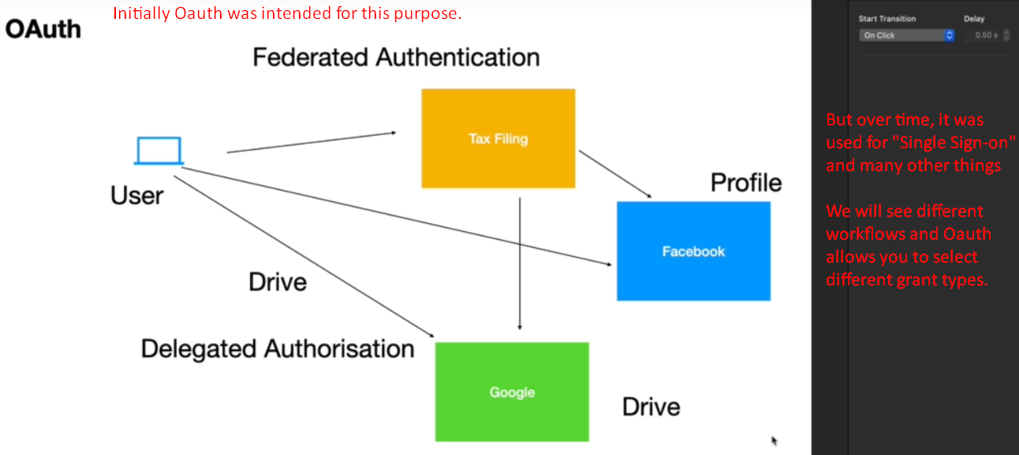
5. There are 4 important components in Oauth which make this Oauth workflow possible.
6. **Components**:
   1. **Resource Server**:
      1. This could be RESTful End-Point or Web App which a client app wants to access.
      2. This is where User Data resides.
7. 